Task 5
import java.io.;
import java.util.;
class Result {
public static int marsExploration(String s) {
int count = 0;

String message = "SOS";

for (int i = 0; i < s.length(); i++) {
if (s.charAt(i) != message.charAt(i % 3)) {
count++;
}
}

return count;
}
}
public class Solution {
public static void main(String[] args) throws IOException {
Scanner sc = new Scanner(System.in);

String s = sc.nextLine();

int result = Result.marsExploration(s);

System.out.println(result);

sc.close();
}
}
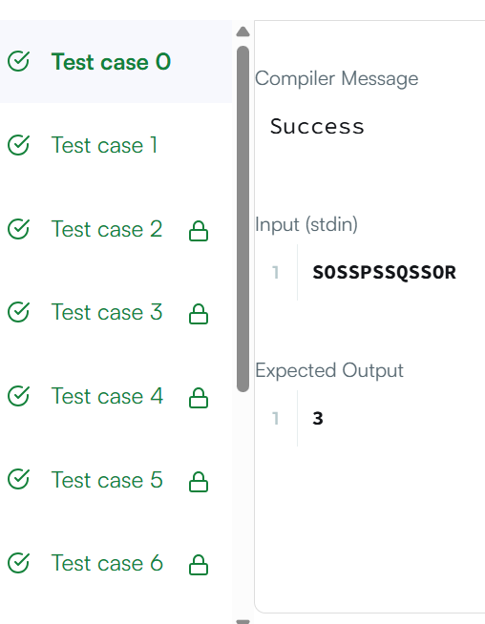
Task 6
import java.util.*;
class Solution {
public List findAnagrams(String s, String p) {
List result = new ArrayList<>();
if (p.length() > s.length()) {
return result;
}

int[] pCount = new int[26];
int[] windowCount = new int[26];

// Count characters in p
for (int i = 0; i < p.length(); i++) {
pCount[p.charAt(i) - 'a']++;
}

int windowSize = p.length();

// First window
for (int i = 0; i < windowSize; i++) {
windowCount[s.charAt(i) - 'a']++;
}

if (Arrays.equals(pCount, windowCount)) {
result.add(0);
}

// Slide the window
for (int i = windowSize; i < s.length(); i++) {

// Add new character
windowCount[s.charAt(i) - 'a']++;

// Remove old character
windowCount[s.charAt(i - windowSize) - 'a']--;

// Check if anagram
if (Arrays.equals(pCount, windowCount)) {
result.add(i - windowSize + 1);
}
}

return result;
}
}
